|  |
| --- |
| List of sampled insurance companies |
| AIICO |
| CONSOLIDATED HALL MARK |
| CORNERSTONE |
| EQUITY ASSURANCE |
| GUINEA |
| LASACO ASSURANCE PLC |
| LAW UNION AND ROCK PLC |
| LEADWAY |
| MANSARD |
| NEM INSURANCE PLC |
| NIGER INSURANCE |
| OASIS |
| ROYAL EXCHANGE |
| SOVEREIGN TRUST INSURANCE PLC |
| STACO |
| UNION ASSURANCE |

**DESCRIPTIVE STATISTICS**

*Table 1*

*Descriptive statistics for mean values of ratio of ceded reinsurance, ratio of reinsurance recoverable to policyholders’ surplus, loss ratio and premium* *growth rate for ten years*.

|  |  |  |  |  |
| --- | --- | --- | --- | --- |
| **INSURANCE COMPANIES** | RCR | RRPHS | LR | PGR |
| AIICO | 0.14947 | 0.0629754 | 0.181037 | 0.43433 |
| CONSOLIDATED HALL MARK | 0.098105 | 0.017292 | 0.137312 | 0.485381 |
| CORNERSTONE | 0.508982 | 0.3144816 | 0.252278 | 51.63527 |
| EQUITY ASSURANCE | 0.06544 | 0.0211488 | 0.744367 | 0.563954 |
| GUINEA | 0.005519 | 0.0193049 | 0.118344 | 0.487648 |
| LASACO ASSURANCE PLC | 0.386503 | 0.083489 | 0.292223 | 1.921024 |
| LAW UNION AND ROCK PLC | 0.234644 | 0.0946953 | 0.244185 | 0.233445 |
| LEADWAY | 0.535225 | 0.0463579 | 0.793177 | 1.599655 |
| MANSARD | 0.105612 | 0.0787508 | 0.149199 | 0.485067 |
| NEM INSURANCE PLC | 0.061935 | 0.0327739 | 0.201145 | 0.427791 |
| NIGER INSURANCE | 0.058437 | 0.0100748 | 0.152222 | 0.329587 |
| OASIS | 0.036131 | 0.0244825 | 0.155647 | 0.180001 |
| ROYAL EXCHANGE | 0.127435 | 0.089328 | 0.453537 | 0.22927 |
| SOVEREIGN TRUST INSURANCE PLC | 0.333765 | 0.001 | 0.210622 | 0.293383 |
| STACO | 0.150106 | 4.1915571 | 0.908735 | 4.363713 |
| UNION ASSURANCE | 0.227034 | 0.0521633 | 0.228971 | 0.184909 |

*Source: financial reports of non-life insurance firms, 2004-2013.*

**4.1 DESCRIPTIVE STATISTICS FOR THE PERIOD OF TEN YEARS FROM 2004 TO 2013**

1. *Table 2: Descriptive statistics for RCR*

|  |  |  |  |  |  |
| --- | --- | --- | --- | --- | --- |
| **INSURANCE COMPANIES** | NO. OF YEARS | MEAN | S.D | MIN | MAX |
| AIICO | 10 | 0.14947 | 0.060582 | 0.072425 | 0.224579 |
| CONSOLIDATED HALL MARK | 10 | 0.098105 | 0.08599 | 0.009847 | 0.258159 |
| CORNERSTONE | 10 | 0.508982 | 0.741312 | 0.041195 | 2.502032 |
| EQUITY ASSURANCE | 10 | 0.06544 | 0.046384 | 0.004177 | 0.147557 |
| GUINEA | 10 | 0.005519 | 0.00616 | 0.000143 | 0.021073 |
| LASACO ASSURANCE PLC | 10 | 0.386503 | 0.46539 | 0.117447 | 1.69131 |
| LAW UNION AND ROCK PLC | 10 | 0.234644 | 0.079957 | 0.109015 | 0.361013 |
| LEADWAY | 10 | 0.535225 | 0.391166 | 0.15194 | 1.565769 |
| MANSARD | 10 | 0.105612 | 0.071448 | 0.024356 | 0.232819 |
| NEM INSURANCE PLC | 10 | 0.061935 | 0.040016 | 0.01002 | 0.142257 |
| NIGER INSURANCE | 10 | 0.058437 | 0.057361 | 0.003705 | 0.18071 |
| OASIS | 10 | 0.036131 | 0.020853 | 0.005427 | 0.080674 |
| ROYAL EXCHANGE | 10 | 0.127435 | 0.072948 | 0.038395 | 0.25158 |
| SOVEREIGN TRUST INSURANCE PLC | 10 | 0.333765 | 0.182208 | 0.117363 | 0.650728 |
| STACO | 10 | 0.150106 | 0.198064 | 0.008061 | 0.700811 |
| UNION ASSURANCE | 10 | 0.227034 | 0.071451 | 0.109566 | 0.381246 |

*Source: financial reports of non-life insurance firms, 2004-2013.*

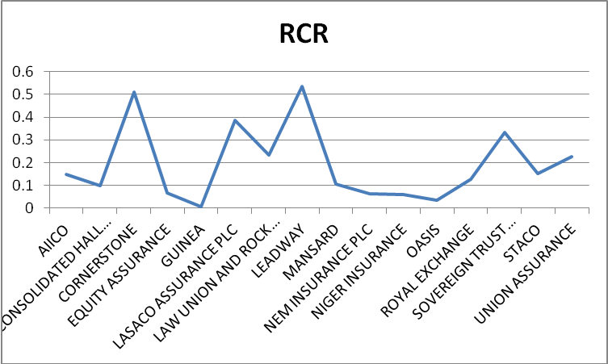

Fig. 1 Line chart of RCR

The table 3 and figure 1 above show the results for *RCR.* This provides information about the extent of reinsurance utilization by insurers for the ten years under study. The result indicates that Leadway assurance mostly transfers risk to reinsurers with an average of 53.5%. This is followed by Cornerstone insurance and Lasaco assurance with average of 50.8% and 38.6% respectively. Guinea insurance cedes the least risk to reinsurers with an average value of 0.55%. Furthermore, the table shows that Cornerstone Insurance has the highest SD of RCR at 0.74. This is followed by Lasaco assurance at 0.46. This result indicates an unstable pattern of reinsurance utilization. The most reliable of the data generated for RCR is from Guinea insurance whose SD is 0.006.

1. *Table 3: Descriptive statistics for premium growth*

|  |  |  |  |  |  |
| --- | --- | --- | --- | --- | --- |
| **INSURANCE COMPANIES** | NO. OF YEARS | MEAN | S.D | MIN | MAX |
| AIICO | 10 | 0.43433 | 0.91472 | -0.11489 | 2.834381 |
| CONSOLIDATED HALL MARK | 10 | 0.485381 | 0.76491 | -0.19333 | 2.250894 |
| CORNERSTONE | 10 | 51.63527 | 153.8443 | -0.99854 | ***461.8809*** |
| EQUITY ASSURANCE | 10 | 0.563954 | 1.998875 | -0.99888 | 5.720576 |
| GUINEA | 10 | 0.487648 | 1.597039 | -0.61491 | 4.682461 |
| LASACO ASSURANCE PLC | 10 | 1.921024 | 5.143817 | -0.38073 | 15.62134 |
| LAW UNION AND ROCK PLC | 10 | 0.233445 | 0.336248 | -0.17289 | 0.883375 |
| LEADWAY | 10 | 1.599655 | 4.005457 | -0.88964 | 12.01693 |
| MANSARD | 10 | 0.485067 | 0.824085 | -0.99741 | 2.060088 |
| NEM INSURANCE PLC | 10 | 0.427791 | 0.611946 | ***-0.10652*** | 1.991589 |
| NIGER INSURANCE | 10 | 0.329587 | 0.615532 | -0.24512 | 1.817861 |
| OASIS | 10 | 0.180001 | 0.446135 | -0.48966 | 1.01479 |
| ROYAL EXCHANGE | 10 | 0.22927 | 0.115375 | 0.081923 | 0.461464 |
| SOVEREIGN TRUST INSURANCE PLC | 10 | 0.293383 | 0.219622 | 0.072286 | 0.753775 |
| STACO | 10 | 4.363713 | 6.810305 | -0.97994 | 15.92626 |
| UNION ASSURANCE | 10 | 0.184909 | 0.320776 | -0.37042 | 0.552477 |

*Source: financial reports of non-life insurance firms, 2004-2013.*

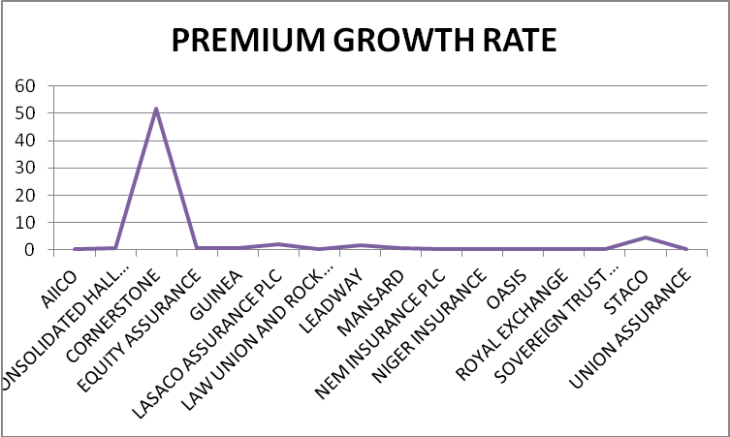

Fig 2 Line chart of premium growth rate.

Table 4 and fig 2 portray the descriptive statistics for Premium Growth Rate (PGR) generated from the study sample for ten years. The result indicates that Cornerstone Insurance has the highest Premium Growth Rate with a mean value of 51.6%. This is followed by Staco insurance and Lasaco assurance at 4.3% and 1.9% respectively. Oasis insurance has the least mean value of PGR at 0.18%*.* In terms of SD**,** Cornerstone insurance has a less reliable data with a SD of 153.8. However, the data generated for Royal Exchange Assurance shows less disparity over the 10 year period with a SD of 0.12. An indication of reliability of PGR.

1. *Table 4: Descriptive statistics for RRPHS*

|  |  |  |  |  |  |
| --- | --- | --- | --- | --- | --- |
| **INSURANCE COMPANIES** | NO. OF YEARS | MEAN | S.D | MIN | MAX |
| AIICO | 10 | 0.062975 | 0.076587 | 0.00939 | 0.231621 |
| CONSOLIDATED HALL MARK | 10 | 0.017292 | 0.025008 | 0.000354 | 0.086715 |
| CORNERSTONE | 10 | 0.314482 | 0.743298 | -0.67227 | 2.159618 |
| EQUITY ASSURANCE | 10 | 0.021149 | 0.024726 | 0.000829 | 0.068692 |
| GUINEA | 10 | 0.019305 | 0.017377 | 0 | 0.044469 |
| LASACO ASSURANCE PLC | 10 | 0.083489 | 0.128751 | 0.011041 | 0.406343 |
| LAW UNION AND ROCK PLC | 10 | 0.094695 | 0.052407 | 0.030125 | 0.195741 |
| LEADWAY | 10 | 0.046358 | 0.053719 | 0.001223 | 0.190734 |
| MANSARD | 10 | 0.078751 | 0.119956 | 0.001887 | 0.375844 |
| NEM INSURANCE PLC | 10 | 0.032774 | 0.022901 | 0.003136 | 0.065084 |
| NIGER INSURANCE | 10 | 0.010075 | 0.005766 | 0.001392 | 0.020228 |
| OASIS | 10 | 0.024483 | 0.017786 | 6.86E-05 | 0.053775 |
| ROYAL EXCHANGE | 10 | 0.089328 | 0.189409 | -0.36059 | 0.365993 |
| SOVEREIGN TRUST INSURANCE PLC | 10 | 1.2 | 3.7 | 0.9 | 1.45234 |
| STACO | 10 | ***4.191557*** | 13.12909 | 0.01073 | 41.55746 |
| UNION ASSURANCE | 10 | 0.052163 | 0.04418 | 0.014237 | 0.150239 |

*Source: financial reports of non-life insurance firms, 2004-2013.*

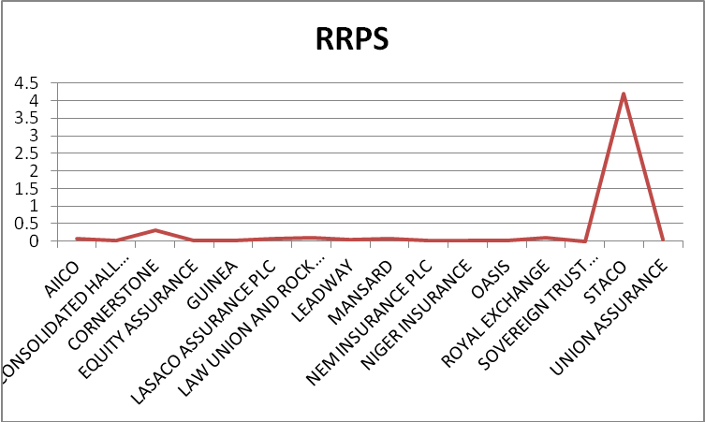

Fig 3 Line chart of RRPHS

Table 5 and Figure 3 show the descriptive statistics results for RRPHS. RRPHS is the measure of dependence of an insurance company on its reinsurers and show the potential exposure to the collectability problems of insurance. STACO insurance has the maximum *RRPHS* for the ten years considered for this study with a mean value of419%. This ratio is quite high and falls outside the acceptable range of between 50% to 150% (Smith, 2011; Iqbal and Rehman, 2014). This indicates that the company depends so much on reinsurance to meet its obligation to policyholders. The table also shows that Sovereign Trust insurance has the lowest RRPHS with an average value of 120%. This means that the company does not depend on reinsurance recoverable for claims payment. The SD ranges from 0.005 for Niger Insurance and 3.7 for Sovereign Trust insurance, this indicates that the mean value for Niger Insurance is a more representative of its average RRPHS when compared to the value for other firms engaged in the study.

1. *Table 5: Descriptive statistics for LR*

|  |  |  |  |  |  |
| --- | --- | --- | --- | --- | --- |
| **INSURANCE COMPANIES** | NO. OF YEARS | MEAN | S.D | MIN | MAX |
| AIICO | 10 | 0.181037 | 0.125628 | 0.06906 | 0.446223 |
| CONSOLIDATED HALL MARK | 10 | 0.137312 | 0.046557 | 0.073153 | 0.242415 |
| CORNERSTONE | 10 | 0.252278 | 0.13306 | 0.012463 | 0.456639 |
| EQUITY ASSURANCE | 10 | 0.744367 | 1.072331 | 0.021406 | 2.918152 |
| GUINEA | 10 | 0.118344 | 0.10005 | 0.003703 | 0.287009 |
| LASACO ASSURANCE PLC | 10 | 0.292223 | 0.457617 | 0.058339 | 1.574559 |
| LAW UNION AND ROCK PLC | 10 | 0.244185 | 0.196408 | 0.126298 | 0.795065 |
| LEADWAY | 10 | 0.793177 | 1.195052 | 0.140756 | 3.146459 |
| MANSARD | 10 | 0.149199 | 0.072772 | 0.013804 | 0.259897 |
| NEM INSURANCE PLC | 10 | 0.201145 | 0.087015 | 0.101564 | 0.371644 |
| NIGER INSURANCE | 10 | 0.152222 | 0.07569 | 0.063385 | 0.292119 |
| OASIS | 10 | 0.155647 | 0.062733 | 0.094349 | 0.303309 |
| ROYAL EXCHANGE | 10 | 0.453537 | 0.296109 | 0.294988 | 1.276327 |
| SOVEREIGN TRUST INSURANCE PLC | 10 | 0.210622 | 0.097981 | 0.118876 | 0.394526 |
| STACO | 10 | 0.908735 | 1.451122 | 0.01547 | 4.589063 |
| UNION ASSURANCE | 10 | 0.228971 | 0.047165 | 0.149795 | 0.318769 |

*Source: financial reports of non-life insurance firms, 2004-2013.*

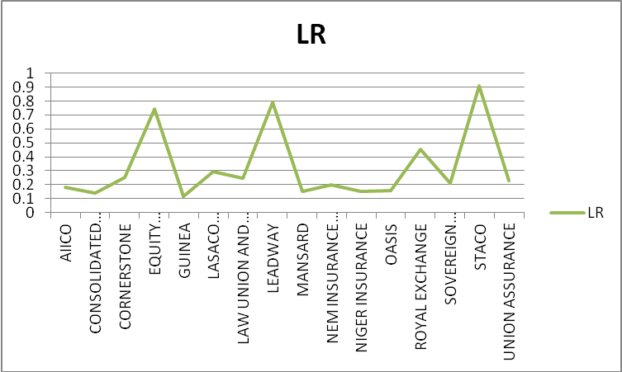

Fig 4 Line chart of LR

Table 6 and Fig 4 show the result of the descriptive analysis for the LR of the sixteen insurance firms engaged in this study. STACO Insurance recorded the highest mean value, an indication that on the average, the firm expend 90.8% of the total premium collected on claim but this is not in the company’s favour because the lower the LR, the more profitable. Guinea Insurance has the lowest mean value of 11.8% which means that only about 12% of their total premium is paid back to policyholders as claim. Leadway Assurance has the highest SD (1.19.) and Consolidated Hallmark Insurance has the lowest SD (0.046). It means that the mean LR value of Consolidated Hallmark Insurance is the most reliable.