List of sampled insurance companies

AIICO
CONSOLIDATED HALL MARK
CORNERSTONE
EQUITY ASSURANCE
GUINEA
LASACO ASSURANCE PLC
LAW UNION AND ROCK PLC
LEADWAY
MANSARD
NEM INSURANCE PLC
NIGER INSURANCE
OASIS
ROYAL EXCHANGE
SOVEREIGN TRUST INSURANCE PLC
STACO
UNION ASSURANCE

DESCRIPTIVE STATISTICS
Table 1
Descriptive statistics for mean values of ratio of ceded reinsurance, ratio of reinsurance recoverable to policyholders’ surplus, loss ratio and premium growth rate for ten years.
INSURANCE COMPANIES | RCR | RRPHS | LR | PGR
AIICO | 0.14947 | 0.0629754 | 0.181037 | 0.43433
CONSOLIDATED HALL MARK | 0.098105 | 0.017292 | 0.137312 | 0.485381
CORNERSTONE | 0.508982 | 0.3144816 | 0.252278 | 51.63527
EQUITY ASSURANCE | 0.06544 | 0.0211488 | 0.744367 | 0.563954
GUINEA | 0.005519 | 0.0193049 | 0.118344 | 0.487648
LASACO ASSURANCE PLC | 0.386503 | 0.083489 | 0.292223 | 1.921024
LAW UNION AND ROCK PLC | 0.234644 | 0.0946953 | 0.244185 | 0.233445
LEADWAY | 0.535225 | 0.0463579 | 0.793177 | 1.599655
MANSARD | 0.105612 | 0.0787508 | 0.149199 | 0.485067
NEM INSURANCE PLC | 0.061935 | 0.0327739 | 0.201145 | 0.427791
NIGER INSURANCE | 0.058437 | 0.0100748 | 0.152222 | 0.329587
OASIS | 0.036131 | 0.0244825 | 0.155647 | 0.180001
ROYAL EXCHANGE | 0.127435 | 0.089328 | 0.453537 | 0.22927
SOVEREIGN TRUST INSURANCE PLC | 0.333765 | 0.001 | 0.210622 | 0.293383
STACO | 0.150106 | 4.1915571 | 0.908735 | 4.363713
UNION ASSURANCE | 0.227034 | 0.0521633 | 0.228971 | 0.184909
Source: financial reports of non-life insurance firms, 2004-2013.

4.1 DESCRIPTIVE STATISTICS FOR THE PERIOD OF TEN YEARS FROM 2004 TO 2013
- Table 2: Descriptive statistics for RCR
INSURANCE COMPANIES | NO. OF YEARS | MEAN | S.D | MIN | MAX
AIICO | 10 | 0.14947 | 0.060582 | 0.072425 | 0.224579
CONSOLIDATED HALL MARK | 10 | 0.098105 | 0.08599 | 0.009847 | 0.258159
CORNERSTONE | 10 | 0.508982 | 0.741312 | 0.041195 | 2.502032
EQUITY ASSURANCE | 10 | 0.06544 | 0.046384 | 0.004177 | 0.147557
GUINEA | 10 | 0.005519 | 0.00616 | 0.000143 | 0.021073
LASACO ASSURANCE PLC | 10 | 0.386503 | 0.46539 | 0.117447 | 1.69131
LAW UNION AND ROCK PLC | 10 | 0.234644 | 0.079957 | 0.109015 | 0.361013
LEADWAY | 10 | 0.535225 | 0.391166 | 0.15194 | 1.565769
MANSARD | 10 | 0.105612 | 0.071448 | 0.024356 | 0.232819
NEM INSURANCE PLC | 10 | 0.061935 | 0.040016 | 0.01002 | 0.142257
NIGER INSURANCE | 10 | 0.058437 | 0.057361 | 0.003705 | 0.18071
OASIS | 10 | 0.036131 | 0.020853 | 0.005427 | 0.080674
ROYAL EXCHANGE | 10 | 0.127435 | 0.072948 | 0.038395 | 0.25158
SOVEREIGN TRUST INSURANCE PLC | 10 | 0.333765 | 0.182208 | 0.117363 | 0.650728
STACO | 10 | 0.150106 | 0.198064 | 0.008061 | 0.700811
UNION ASSURANCE | 10 | 0.227034 | 0.071451 | 0.109566 | 0.381246
Source: financial reports of non-life insurance firms, 2004-2013.

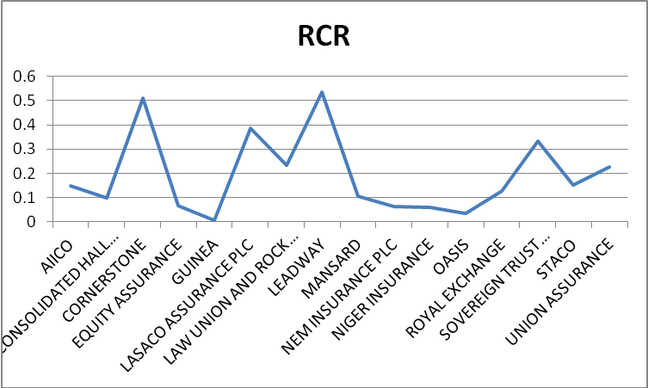
Fig. 1 Line chart of RCR
The table 3 and figure 1 above show the results for RCR. This provides information about the extent of reinsurance utilization by insurers for the ten years under study. The result indicates that Leadway assurance mostly transfers risk to reinsurers with an average of 53.5%. This is followed by Cornerstone insurance and Lasaco assurance with average of 50.8% and 38.6% respectively. Guinea insurance cedes the least risk to reinsurers with an average value of 0.55%. Furthermore, the table shows that Cornerstone Insurance has the highest SD of RCR at 0.74. This is followed by Lasaco assurance at 0.46. This result indicates an unstable pattern of reinsurance utilization. The most reliable of the data generated for RCR is from Guinea insurance whose SD is 0.006.

- Table 3: Descriptive statistics for premium growth
INSURANCE COMPANIES | NO. OF YEARS | MEAN | S.D | MIN | MAX
AIICO | 10 | 0.43433 | 0.91472 | -0.11489 | 2.834381
CONSOLIDATED HALL MARK | 10 | 0.485381 | 0.76491 | -0.19333 | 2.250894
CORNERSTONE | 10 | 51.63527 | 153.8443 | -0.99854 | 461.8809
EQUITY ASSURANCE | 10 | 0.563954 | 1.998875 | -0.99888 | 5.720576
GUINEA | 10 | 0.487648 | 1.597039 | -0.61491 | 4.682461
LASACO ASSURANCE PLC | 10 | 1.921024 | 5.143817 | -0.38073 | 15.62134
LAW UNION AND ROCK PLC | 10 | 0.233445 | 0.336248 | -0.17289 | 0.883375
LEADWAY | 10 | 1.599655 | 4.005457 | -0.88964 | 12.01693
MANSARD | 10 | 0.485067 | 0.824085 | -0.99741 | 2.060088
NEM INSURANCE PLC | 10 | 0.427791 | 0.611946 | -0.10652 | 1.991589
NIGER INSURANCE | 10 | 0.329587 | 0.615532 | -0.24512 | 1.817861
OASIS | 10 | 0.180001 | 0.446135 | -0.48966 | 1.01479
ROYAL EXCHANGE | 10 | 0.22927 | 0.115375 | 0.081923 | 0.461464
SOVEREIGN TRUST INSURANCE PLC | 10 | 0.293383 | 0.219622 | 0.072286 | 0.753775
STACO | 10 | 4.363713 | 6.810305 | -0.97994 | 15.92626
UNION ASSURANCE | 10 | 0.184909 | 0.320776 | -0.37042 | 0.552477
Source: financial reports of non-life insurance firms, 2004-2013.

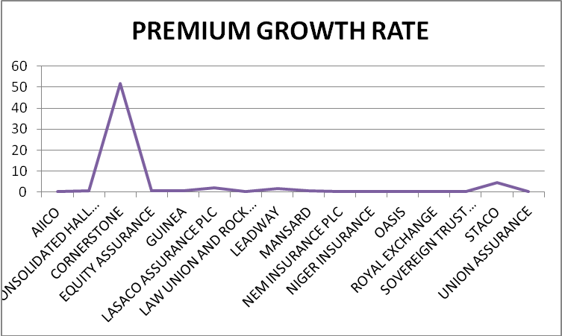
Fig 2 Line chart of premium growth rate.
Table 4 and fig 2 portray the descriptive statistics for Premium Growth Rate (PGR) generated from the study sample for ten years. The result indicates that Cornerstone Insurance has the highest Premium Growth Rate with a mean value of 51.6%. This is followed by Staco insurance and Lasaco assurance at 4.3% and 1.9% respectively. Oasis insurance has the least mean value of PGR at 0.18%. In terms of SD, Cornerstone insurance has a less reliable data with a SD of 153.8. However, the data generated for Royal Exchange Assurance shows less disparity over the 10 year period with a SD of 0.12. An indication of reliability of PGR.

- Table 4: Descriptive statistics for RRPHS
INSURANCE COMPANIES | NO. OF YEARS | MEAN | S.D | MIN | MAX
AIICO | 10 | 0.062975 | 0.076587 | 0.00939 | 0.231621
CONSOLIDATED HALL MARK | 10 | 0.017292 | 0.025008 | 0.000354 | 0.086715
CORNERSTONE | 10 | 0.314482 | 0.743298 | -0.67227 | 2.159618
EQUITY ASSURANCE | 10 | 0.021149 | 0.024726 | 0.000829 | 0.068692
GUINEA | 10 | 0.019305 | 0.017377 | 0 | 0.044469
LASACO ASSURANCE PLC | 10 | 0.083489 | 0.128751 | 0.011041 | 0.406343
LAW UNION AND ROCK PLC | 10 | 0.094695 | 0.052407 | 0.030125 | 0.195741
LEADWAY | 10 | 0.046358 | 0.053719 | 0.001223 | 0.190734
MANSARD | 10 | 0.078751 | 0.119956 | 0.001887 | 0.375844
NEM INSURANCE PLC | 10 | 0.032774 | 0.022901 | 0.003136 | 0.065084
NIGER INSURANCE | 10 | 0.010075 | 0.005766 | 0.001392 | 0.020228
OASIS | 10 | 0.024483 | 0.017786 | 6.86E-05 | 0.053775
ROYAL EXCHANGE | 10 | 0.089328 | 0.189409 | -0.36059 | 0.365993
SOVEREIGN TRUST INSURANCE PLC | 10 | 1.2 | 3.7 | 0.9 | 1.45234
STACO | 10 | 4.191557 | 13.12909 | 0.01073 | 41.55746
UNION ASSURANCE | 10 | 0.052163 | 0.04418 | 0.014237 | 0.150239
Source: financial reports of non-life insurance firms, 2004-2013.

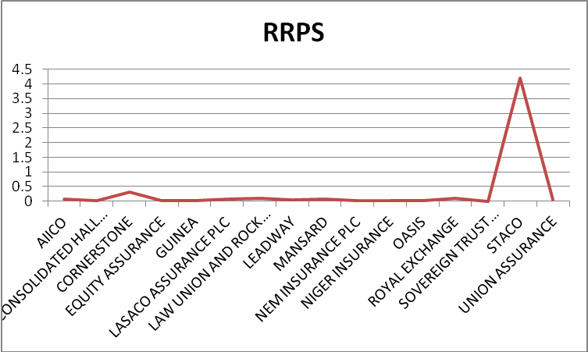
Fig 3 Line chart of RRPHS

Table 5 and Figure 3 show the descriptive statistics results for RRPHS. RRPHS is the measure of dependence of an insurance company on its reinsurers and show the potential exposure to the collectability problems of insurance. STACO insurance has the maximum RRPHS for the ten years considered for this study with a mean value of 419%. This ratio is quite high and falls outside the acceptable range of between 50% to 150% (Smith, 2011; Iqbal and Rehman, 2014). This indicates that the company depends so much on reinsurance to meet its obligation to policyholders. The table also shows that Sovereign Trust insurance has the lowest RRPHS with an average value of 120%. This means that the company does not depend on reinsurance recoverable for claims payment. The SD ranges from 0.005 for Niger Insurance and 3.7 for Sovereign Trust insurance, this indicates that the mean value for Niger Insurance is a more representative of its average RRPHS when compared to the value for other firms engaged in the study.

- Table 5: Descriptive statistics for LR
INSURANCE COMPANIES | NO. OF YEARS | MEAN | S.D | MIN | MAX
AIICO | 10 | 0.181037 | 0.125628 | 0.06906 | 0.446223
CONSOLIDATED HALL MARK | 10 | 0.137312 | 0.046557 | 0.073153 | 0.242415
CORNERSTONE | 10 | 0.252278 | 0.13306 | 0.012463 | 0.456639
EQUITY ASSURANCE | 10 | 0.744367 | 1.072331 | 0.021406 | 2.918152
GUINEA | 10 | 0.118344 | 0.10005 | 0.003703 | 0.287009
LASACO ASSURANCE PLC | 10 | 0.292223 | 0.457617 | 0.058339 | 1.574559
LAW UNION AND ROCK PLC | 10 | 0.244185 | 0.196408 | 0.126298 | 0.795065
LEADWAY | 10 | 0.793177 | 1.195052 | 0.140756 | 3.146459
MANSARD | 10 | 0.149199 | 0.072772 | 0.013804 | 0.259897
NEM INSURANCE PLC | 10 | 0.201145 | 0.087015 | 0.101564 | 0.371644
NIGER INSURANCE | 10 | 0.152222 | 0.07569 | 0.063385 | 0.292119
OASIS | 10 | 0.155647 | 0.062733 | 0.094349 | 0.303309
ROYAL EXCHANGE | 10 | 0.453537 | 0.296109 | 0.294988 | 1.276327
SOVEREIGN TRUST INSURANCE PLC | 10 | 0.210622 | 0.097981 | 0.118876 | 0.394526
STACO | 10 | 0.908735 | 1.451122 | 0.01547 | 4.589063
UNION ASSURANCE | 10 | 0.228971 | 0.047165 | 0.149795 | 0.318769
Source: financial reports of non-life insurance firms, 2004-2013.

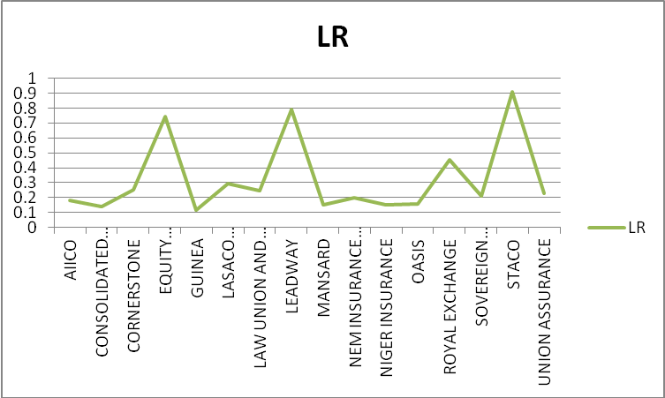
Fig 4 Line chart of LR
Table 6 and Fig 4 show the result of the descriptive analysis for the LR of the sixteen insurance firms engaged in this study. STACO Insurance recorded the highest mean value, an indication that on the average, the firm expend 90.8% of the total premium collected on claim but this is not in the company’s favour because the lower the LR, the more profitable. Guinea Insurance has the lowest mean value of 11.8% which means that only about 12% of their total premium is paid back to policyholders as claim. Leadway Assurance has the highest SD (1.19.) and Consolidated Hallmark Insurance has the lowest SD (0.046). It means that the mean LR value of Consolidated Hallmark Insurance is the most reliable.

